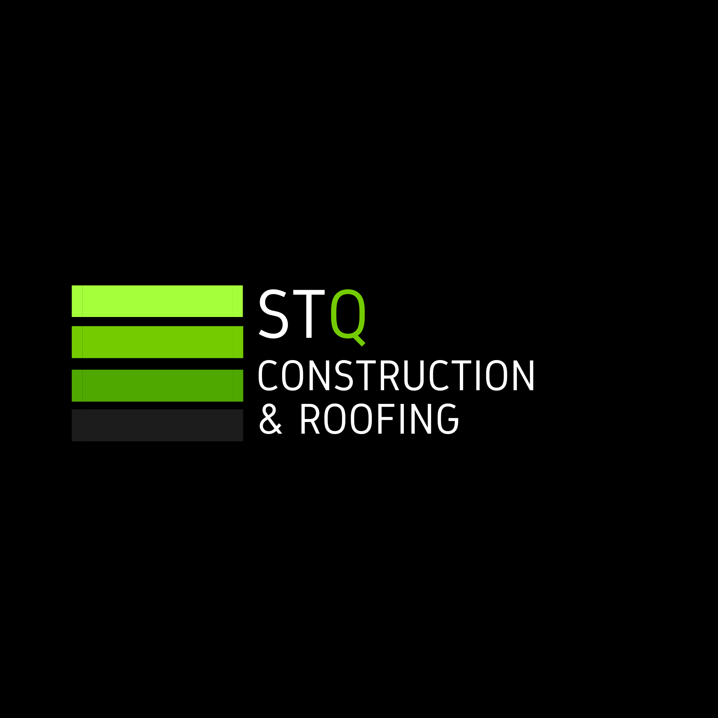

SUBCONTRACTOR
CHECKLIST

Residential & Commercial Construction

STQ Construction & Roofing LLC

Florida Certified Building Contractor | Florida Certified Roofing Contractor

CBC1270631 | CCC1337865

Master Subcontractor Agreement | Version 2026.1

STQ CONSTRUCTION & ROOFING
STQ SUBCONTRACTOR APPLICATION & PREQUALIFICATION FORM

1. COMPANY INFORMATION
Legal Business Name*
Click or tap here to enter text.
____________________________________________________________
DBA / Trade Name
Click or tap here to enter text.
____________________________________________________________
Business Entity Type*
Choose an item.
Year Business Established*
Click or tap to enter a date.
Business Address*
Click or tap here to enter text.
____________________________________________________________
City*
Click or tap here to enter text.
____________________________________________________________
State*
Click or tap here to enter text.
____________________________________________________________
ZIP Code*
Click or tap here to enter text.
____________________________________________________________
Company Phone Number*
Click or tap here to enter text.
____________________________________________________________
Company Email Address*
Click or tap here to enter text.
____________________________________________________________
Website
Click or tap here to enter text.
____________________________________________________________

2. PRIMARY CONTACT
Owner / Principal Name*
Click or tap here to enter text.
____________________________________________________________
Title*
Click or tap here to enter text.
____________________________________________________________
Direct Phone Number*
Click or tap here to enter text.
____________________________________________________________
Email Address*
Click or tap here to enter text.
____________________________________________________________
Best Method of Contact
Choose an item.

3. TRADES & SERVICES
Primary Trade*
☐ Roofing – Shingle
☐ Roofing – Tile
☐ Roofing – Metal
☐ Roofing – Flat / Low-Slope
☐ Roofing Repair
☐ General Construction
☐ Remodeling
☐ Restoration / Build-Back
☐ Framing / Carpentry
☐ Concrete
☐ Masonry / CMU
☐ Stucco
☐ Siding
☐ Drywall
☐ Insulation
☐ Painting
☐ Flooring
☐ Tile
☐ Waterproofing
☐ Cabinets / Millwork
☐ Countertops
☐ Windows
☐ Doors / Glass
☐ Plumbing
☐ Electrical
☐ HVAC
☐ Gutters
☐ Fencing
☐ Landscaping / Irrigation
☐ Demolition
☐ Debris Removal / Cleanup
☐ Other

Briefly Describe the Work Your Company Performs*
Long-answer field

4. SERVICE AREA
What Florida counties or areas do you service?*
- ☐Central Florida
- ☐Orlando / Orange County
- ☐Osceola County
- ☐Seminole County
- ☐Lake County
- ☐Polk County
- ☐Volusia County
- ☐Brevard County
- ☐Hillsborough / Tampa Bay
- ☐Pinellas County
- ☐Pasco County
- ☐Sarasota / Manatee
- ☐South Florida
- ☐Miami-Dade
- ☐Broward
- ☐Palm Beach
- ☐Statewide Florida
- ☐Other
Click or tap here to enter text.

Maximum Distance You Will Travel for a Project
- ☐25 miles
- ☐50 miles
- ☐75 miles
- ☐100 miles
- ☐150+ miles
- ☐Statewide

5. PROJECT CAPABILITIES
Which types of projects do you perform?
- ☐Residential
- ☐Multifamily
- ☐Commercial
- ☐Restoration / Property Damage
- ☐Insurance-Related Repairs
- ☐Remodeling
- ☐New Construction
- ☐Service / Repair Work
- ☐Emergency Work
Typical Crew Size*
Number
Number of Crews Available*
Number
How many projects can you reasonably handle at one time?
Number
Emergency / After-Hours Service Available?*
☐Yes / ☐No
Weekend Work Available?
☐Yes / ☐No

6. EXPERIENCE
Years Performing Your Primary Trade*
Number
Typical Project Size
- ☐Under $5,000
- ☐$5,000–$25,000
- ☐$25,000–$50,000
- ☐$50,000–$100,000
- ☐$100,000–$250,000
- ☐$250,000+
- ☐Varies
Largest Project Completed in the Last 3 Years
Dollar amount
Briefly Describe Your Experience*
Long answer

7. LICENSING
Does your trade require a Florida contractor or professional license?*
☐Yes / ☐No / ☐Unsure
If Yes, conditional fields appear:
License Type - Click or tap here to enter text.
Florida License Number - Click or tap here to enter text.
License Holder / Qualifying Agent
Click or tap here to enter text.

License Expiration Date
Click or tap here to enter text.
Is the License Currently Active?
☐Yes / ☐No
Upload:
Contractor / Trade License

8. LOCAL REGISTRATION
Do you currently hold a Business Tax Receipt?
☐Yes / ☐No
Are you registered to perform work in any Florida counties or municipalities?
☐Yes / ☐No
If Yes:
List Jurisdictions
Long answer
Upload:
Business Tax Receipt / Local Registration

9. GENERAL LIABILITY INSURANCE
Do you currently carry Commercial General Liability Insurance?*
☐Yes / ☐No
If Yes:
General Liability – Each Occurrence Limit*
- ☐$500,000
- ☐$1,000,000
- ☐$2,000,000+
- ☐Other
General Aggregate Limit*
- ☐$1,000,000
- ☐$2,000,000
- ☐$4,000,000+
- ☐Other
Insurance Carrier
Policy Expiration Date: Click or tap here to enter text.
Can your insurance carrier name STQ Construction & Roofing LLC as an Additional Insured when required?*
☐Yes / ☐No / ☐Unsure
Can your policy provide Primary & Non-Contributory coverage when required?*
☐Yes / ☐No / ☐Unsure
Can your carrier provide Waiver of Subrogation when required?*
☐Yes / ☐No / ☐Unsure
Upload:
Certificate of Insurance (COI)
Optional at initial application or required if you want to screen immediately.
The COI upload optional, but required before final approval.

10. WORKERS' COMPENSATION
Workers' Compensation Status*
- ☐Workers' Compensation Policy
- ☐Florida Workers' Compensation Exemption
- ☐Neither
- ☐Unsure
If policy:
Carrier: Click or tap here to enter text.
Policy Expiration Date: Click or tap here to enter text.
If exemption:
Exemption Holder: Click or tap here to enter text.
Exemption Expiration Date: Click or tap here to enter text.
Upload:
Workers' Compensation Certificate or Exemption
This optional at the application stage but mandatory during formal onboarding.

11. COMMERCIAL AUTOMOBILE
Do you maintain Automobile Liability Insurance for vehicles used in your business?*
☐Yes / ☐No
Auto Liability Limit
- ☐Under $1,000,000
- ☐$1,000,000
- ☐More than $1,000,000
- ☐Unsure
Do you use company-owned vehicles?
☐Yes / ☐No

12. UMBRELLA / SPECIALTY INSURANCE
Do you maintain Umbrella / Excess Liability Insurance?
☐Yes / ☐No

If Yes:
Limit: $Click or tap here to enter text.
Then:
Do you maintain any specialty insurance applicable to your work?
- ☐Professional Liability
- ☐Contractors Pollution Liability
- ☐Installation Floater
- ☐Inland Marine
- ☐Cyber Liability
- ☐Other
- ☐None

13. TRADE CERTIFICATIONS
Do you hold manufacturer or trade-specific certifications?
☐Yes / ☐No
If Yes:
Certification / Manufacturer
Long answer
Examples could include roofing manufacturer certifications, equipment certifications, specialty installation credentials, etc.
Upload:
Trade / Manufacturer Certifications

14. SAFETY
Does your company maintain a written safety program?*
☐Yes / ☐No
Do you provide safety training appropriate to your trade?*
☐Yes / ☐No
Do you designate Competent Persons when required?*
☐Yes / ☐No / ☐Not Applicable
Do employees receive fall-protection training when applicable?
☐Yes / ☐No / ☐N/A
Have you had a serious OSHA citation within the past 3 years?*
☐Yes / ☐No
If Yes:
Please Explain
Long answer

15. LOWER-TIER SUBCONTRACTORS
Do you use Lower-Tier Subcontractors to perform any portion of your work?*
☐Yes / ☐No
If Yes:
What work do you typically subcontract?
Long answer
Then:
☐I understand that STQ approval of my company does not automatically approve any Lower-Tier Subcontractor.

16. REFERENCES
Reference 1:
Company / Customer Name*
Click or tap here to enter text.
Contact Name*
Click or tap here to enter text.
Phone*
Click or tap here to enter text.
Email
Click or tap here to enter text.
Type of Work Performed*
Click or tap here to enter text.
Reference 2
Company / Customer Name*
Click or tap here to enter text.
Contact Name*
Click or tap here to enter text.
Phone*
Click or tap here to enter text.
Email
Click or tap here to enter text.
Type of Work Performed*
Click or tap here to enter text.

17. EXPERIENCE WITH GENERAL CONTRACTORS / PROPERTY CLAIM WORK
Have you previously worked as a subcontractor for a general contractor?*
☐Yes / ☐No
Do you have experience with restoration or insurance-related property repairs?
☐Yes / ☐No
Are you familiar with documented scopes of work and written Change Order procedures?
☐Yes / ☐No
Are you comfortable submitting project photographs and documentation electronically?*
☐Yes / ☐No
Are you comfortable using a Contractor Project Management Platform for project administration?*
☐Yes / ☐No

18. PAYMENT & ADMINISTRATION
Accounting Contact Name
Click or tap here to enter text.
Accounting Email
Click or tap here to enter text.
Accounting Phone
Click or tap here to enter text.
☐ I understand that invoices and Payment Applications must comply with STQ's documentation requirements.
☐ I understand that additional or changed Work must be approved by STQ before the Work is performed, except where otherwise permitted by contract.
☐ I understand that approval as an STQ subcontractor does not guarantee any minimum amount of Work.

19. DOCUMENT UPLOAD SECTION
Document | Application
Contractor / Trade License | Recommended
Certificate of Insurance | Recommended
Workers' Comp Certificate / Exemption | Recommended
Business Tax Receipt | Optional
Manufacturer Certifications | Optional
Safety Certifications | Optional
Company Capability Statement | Optional
Project Photos / Portfolio | Optional

20. ADDITIONAL INFORMATION
Why are you interested in working with STQ Construction & Roofing?
Long answer.
Is there anything else we should know about your company?
Long answer.

21. REQUIRED CERTIFICATION & ACKNOWLEDGMENTS
☐ I certify that the information provided in this application is accurate and complete to the best of my knowledge.
☐ I understand that submission of this application does not constitute approval as an STQ subcontractor, an award of Work, or authorization to perform Work on any STQ Project.
☐ I understand that, if selected to proceed, my company will be required to complete STQ's formal subcontractor onboarding and compliance process.
☐ I understand that formal onboarding may require execution of STQ's Master Contractor/Subcontractor Agreement and submission of insurance, licensing, tax, Workers' Compensation, certification, and other compliance documentation.
☐ I understand that each individual STQ Project requires separate Project-specific authorization before Work may commence.
☐ I authorize STQ Construction & Roofing LLC to verify licenses, insurance, references, and other business information submitted as part of this application.

Authorized Representative Name*
Click or tap here to enter text.
Title*
Click or tap here to enter text.
Company*
Click or tap here to enter text.
Electronic Signature*
Date*
Click or tap to enter a date.

